
COMMUNITY TRANSLATION GUIDELINES – BASIC GUIDELINES

BASIC GUIDELINES FOR COMMUNITY TRANSLATION
The Basic Guidelines for Community Translation briefly cover the fundamentals of translating Football Manager using LTF files. Understanding LTFs, using them to create translations, saving and encoding them for use, using them within the game and publishing them to Steam Workshop are all covered below. For more detailed guidelines first familiarise yourself with the basics and then read on in the Advanced Guidelines for Community Translation below.

INTRODUCTION

- Creating a Community Translation of Football Manager is a relatively simple task, translate all the text that appears in the game into your desired target language.
- The “example.ltf” file contains the English source text of every string in the game so a complete translation of every string in the LTF file will provide a complete translation for Football Manager*
- LTF stands for Language Text File
- A “string” is a line of text. It can range in length from just one character to a complete set of multiple sentences.
- The “example.ltf” file is very large as it contains a significant amount of text. To edit it we’d recommend using a text editor that can handle extremely large files. Some free suggestions:
  - Windows: Notepad++
  - Mac: Textwrangler
- LTF files MUST be saved with UTF8 encoding without byte-order-marker, or “BOM”

*Note that strings are stored and translated separately from “entity” names like Agreements, Awards, Clubs, Cities, Competitions, Continents, Currencies, Derbies, Descriptions, Injuries, Languages, Local Regions, Media Sources, Nations, People, Stadiums, Stage Names and Weather etc. For information on translating entity names see the “Translating Entities Using the Football Manager 2023 Editor” in the Advanced Guide section below.

USING AN LTF FILE

- When first opening up an LTF the user can specify the following:

  - “LANGNAME:” is the name of your language as it will appear in Football Manager’s preferences. If set to “Martian” then that’s how it will appear in the list of available languages in-game. For example:

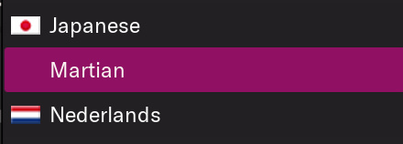
  - “GENDERS:” reserved for internal use (please leave this set to “0”)
  - “BASESTRINGS:” reserved for internal use (please leave this set to “0”)
  - Note there is currently no way for Users to add a flag to a new translation

- Below this the strings for Football Manager appear with ID, source text, comment and translation area:

TRANSLATING IN AN LTF FILE
- To translate a string simply enter your target language translation of the English source text after the “STR-1: ” header.
  - Do not overwrite the English source text
  - You do not need to translate the “[COMMENT]” section of the string.
  - Make sure to leave a space after “STR-1:”. For example “STR-1: Your translation…”
  - Where possible try to keep the translation to a similar length to the English source text (if your translations are much longer you may encounter user interface issues)
- Here’s an example of a simple string translated into Latin:

KEY-227481: Accept all loan offers[COMMENT: transfer offer options; set transfer status screen]
STR-1: Accipies mutuum dedi omnes

- Some strings are more complex than the one above. They may contain “variables” (code placeholders for entities that will vary depending on the user’s game) and/or formatting to make the string appear correctly within game.
- Here’s an example of a string containing two variables:
KEY-261373: [%team#1-short] kept a clean sheet today and have gone [%number#1] games without conceding, beating the previous all-time record[COMMENT: pre-match screen; milestones]
- When this string appears in-game “[%team#1-short]” will be replaced by a team name (for example “Everton”) and “[%number#1]” will be replaced by a number.
- When making translations be aware of what text might appear in the space occupied by a variable. For example, note that all Clubs in English are treated as plural (e.g. “Watford have”, “Everton are”). They may be singular in your language.

SAVING AND ENCODING AN LTF FILE
- Remember to save early and save often, always using UTF-8 encoding without byte-order-marker, or “BOM”
- LTF files for use in Football Manager 2023 should be save in the following folder so the game can read them: C:\Users\[YOURUSERNAME]\Documents\Sports Interactive\Football Manager 2023\Languages
- Encoding settings vary between different text editors. This is how to encode the LTF correctly in Notepad++ for Windows

USING YOUR LTF FILE IN-GAME

- When you’re ready to use your new file in-game navigate to “Preferences > Overview > Language” (from either the Main Menu screen or within a game by selecting the “FM” menu at the top right of the screen) and select your new language from the dropdown.
- Make sure any files you wish to use in-game are saved in the following folder: C:\Users\[YOURUSERNAME]\Documents\Sports Interactive\Football Manager 2023\Language
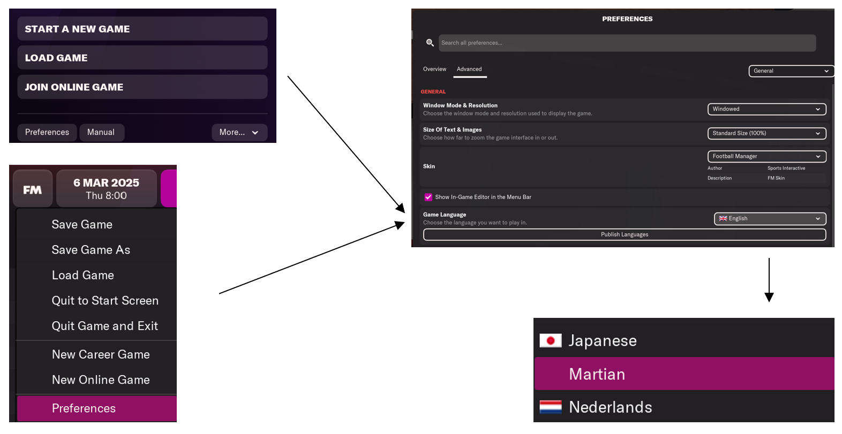
PUBLISHING YOUR LTF FILE USING STEAM WORKSHOP
- Using Steam Workshop you are able to share any translations you’ve created.
- Navigate to “Preferences > Overview” and select the “Publish Languages” button:

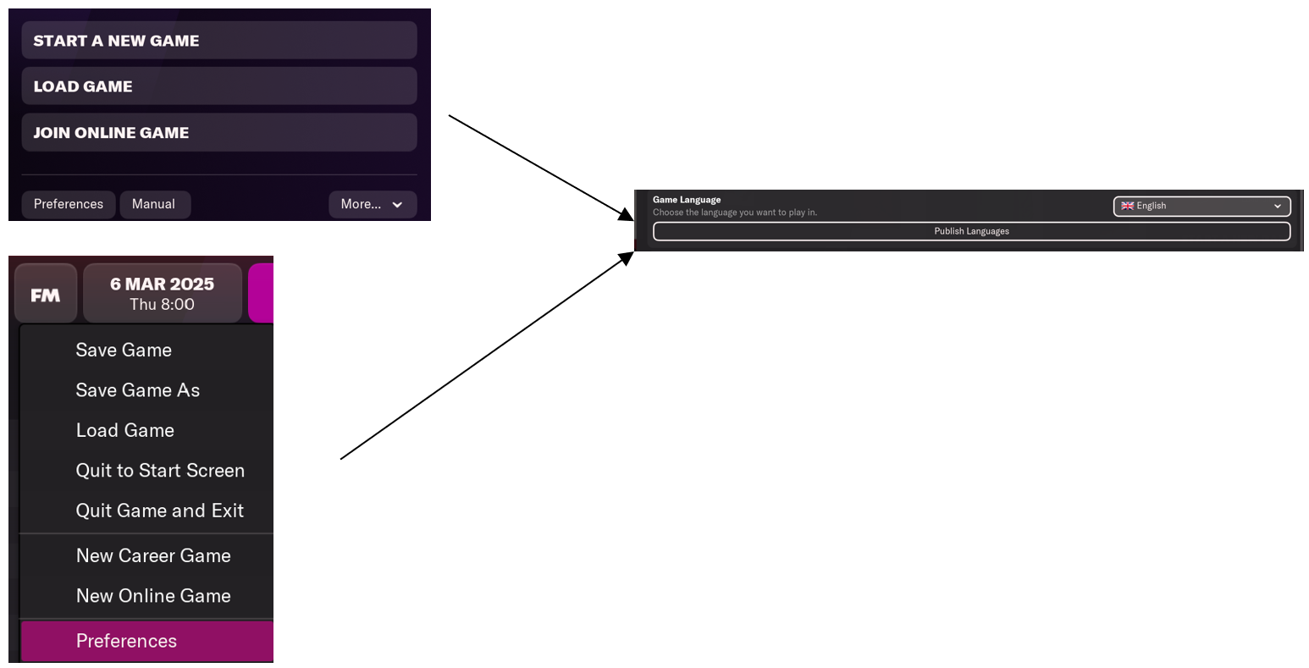
- Then simply follow the “Publish to Steam Workshop” wizard to share your translations.
- Note that the wizard will only display LTF files saved in the following folder: C:\Users\[YOURUSERNAME]\Documents\Sports Interactive\Football Manager 2023\Language

www.sigames.com / www.community.sigames.com

